DIFFERENTIAL EQUATIONS OF STIFFENED PANELS

NA 510
NA&ME
University of Michigan

Philippe RIGO (*)

Visiting Professor

(*) Dept. of Naval Architecture, ANAST, University of Liege, Belgium

Ann Arbor, MICHIGAN March 2001

DIFFERENTIAL EQUATIONS OF STIFFENED PANELS.
&
FOURIER SERIES EXPANSIONS

INTRODUCTION

This text presents the theory used to implement in the LBR5 software an analytical solution of the stiffened panels governing equations. For that purpose, Fourier series expansions are used to solve the governing differential equations.

In the present analysis, cylindrical shells are used as the reference panels. Stiffened plates are considered as a simplified case of the more general cylindrical shell. In the LBR-5 software, plates are analyzed as being cylindrical shells having a very large radius (q=1.0 10¹⁰ m).

The present method has been developed for fast and accurate linear elastic analysis of stiffened structures, particularly in regard to structural optimization.

DIFFERENTIAL EQUATIONS OF THE CYLINDRICAL STIFFENED SHELL

Figure 1 shows the coordinate system (oxϕ) with z=0 at mid plate thickness. The relation between the ϕ coordinate (used for shell) and the y coordinate is: y=qϕ.
Q is the radius, δ the plate thickness, L the panel length (along x) and ϕ₀ the opening angle (radian).
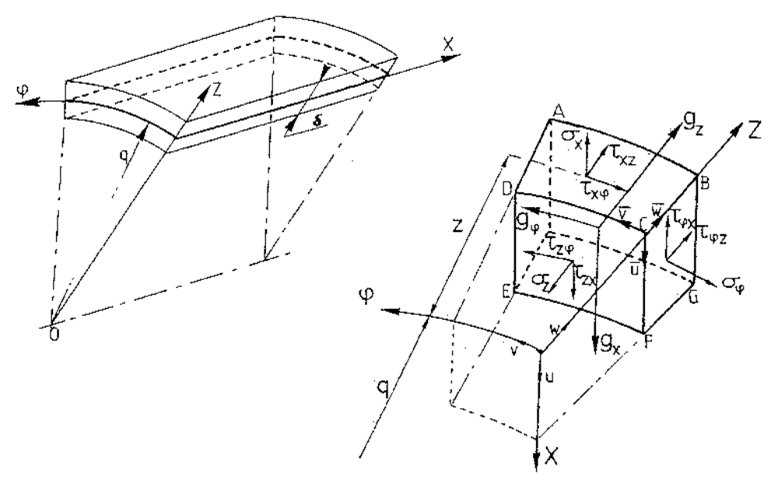

Figure 1: The panel coordinate system
The stresses acting on a small volume element [dx dz (q+z) dϕ] are presented in Figure 1. But for this study, the thin shell (plate) theory is used. This means that τ_{xz} , τ_{ϕz} and σ_{z} are not considered (ε_{z} , γ_{xz} and γ_{ϕz} = 0).

The proposed governing differential equations are known as the D.K.J. differential equations (Donnell, von Karman and Jenkins). They are based on the Love-Kirchoff hypotheses.

These hypotheses are the following:
- Thin shell theory. This means that δ/q <<< 1 and that δ/q is negligible with regard to 1. For LBR5, we impose that δ/q < 1/100.
- Small deformation and linear analysis,
- The points that are on a perpendicular line to the mid plate surface (z=0) before deformation remain on the same perpendicular after deformation, so γ_{xz} and γ_{ϕz} = 0.
- σ_{z} and its effects are negligible.
- No deformation along oz (ε_{z} =0).

Therefore, the linear “deformation-displacement” relationships are (Eq.1):
SHELL 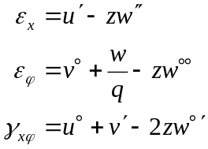 PLATE 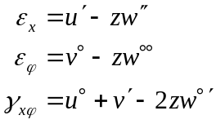 [1]

and the “stress-displacement” relationships are (Eq.2):
SHELL 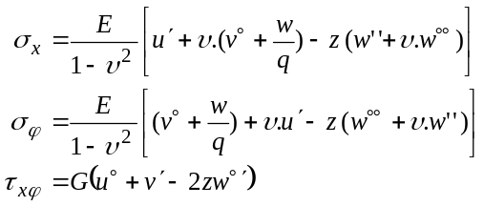 [2]

PLATE 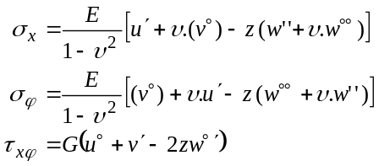

With E = the Young Modulus
ν = the Poisson Coefficient
G = the Shear Modulus = E / 2(1+ν)

Note: the derivation of a f function according to the x and y variables are noted:

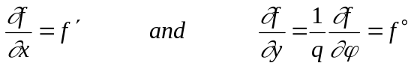 [3]
Figure 2 shows the internal resultant forces and moments that are applied on an elementary cylindrical shell (plate). Hereafter they are called “resultants”. This element is included between the upper surface (z=-δ/2) and the lower surface (z=-δ/2) and has a surface dimension of dx.qdϕ (or dx dy)

Resultant forces: Nx, Qx, Nxϕ,
Nϕ, Qϕ, Nϕx,

Resultant moments: Mx, Mxϕ, Mϕ, Mϕx

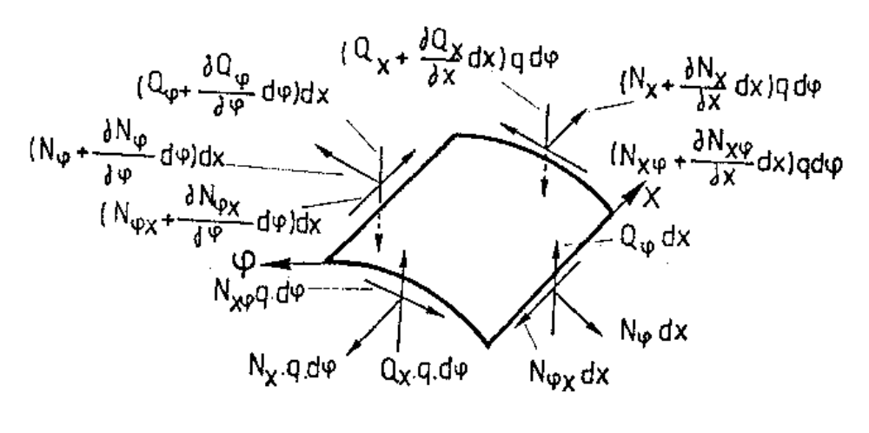

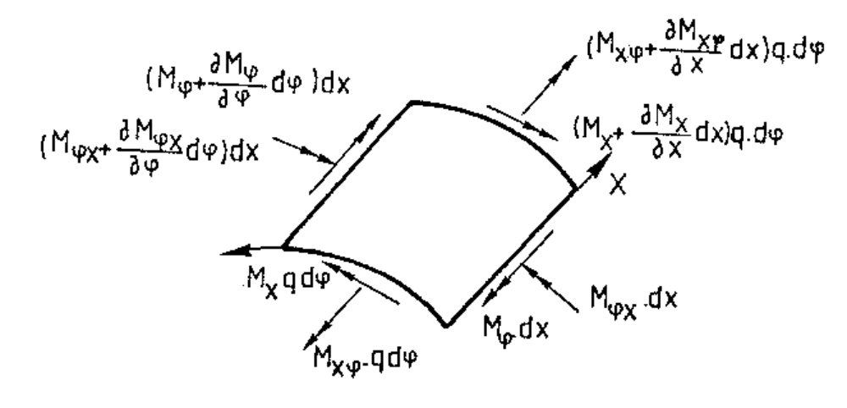

Figure 2 : Resultant forces and Resultant moments
With reference to the thin shell element (Figure 2), we can establish the “resultant-stress” relationships (Eqs.4). These resultant forces and moments are referenced to the plate neutral axis (z=0).
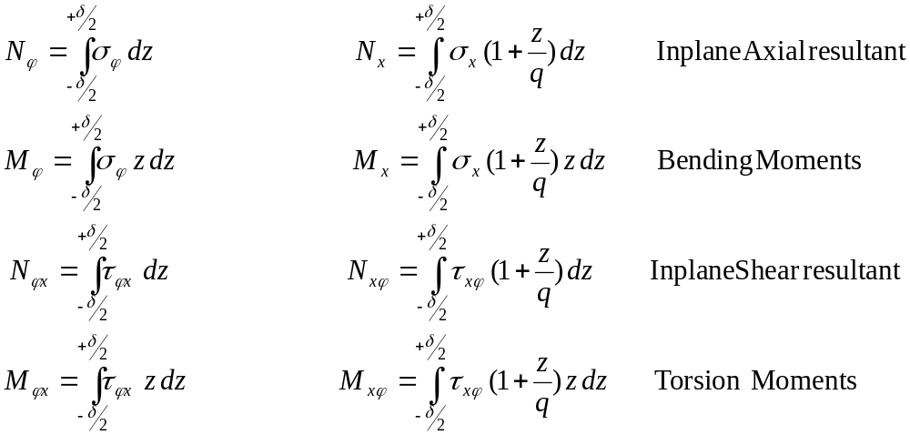 [4]

Q_{x} and Q_{ϕ} (transverse shear resultant) cannot be calculated by integration of the τ_{xz} and τ_{ϕz} stresses as these shear stresses are assumed to be equal to 0 (thin plate assumption). Nevertheless, Q_{x} and Q_{ϕ} can be evaluated using the 4th and the 5th equilibrium equations (Eqs.8).

If we replace the “stress-displacement” relationships [Eqs.2] within the “resultant-stress” relationships [Eq.4] we obtain the “resultant-displacement” relationships [Eqs.5].
SHELL 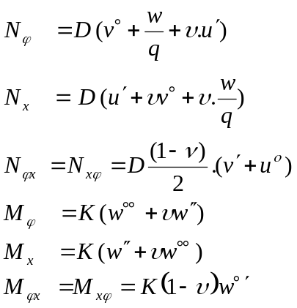 [5a]

PLATE 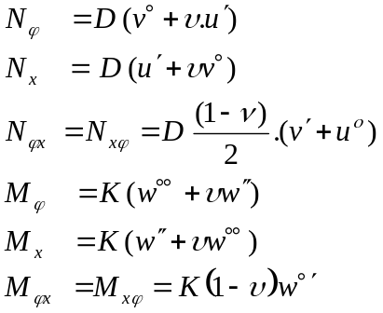 [5b]
with: 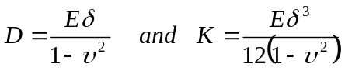
Figure 3 shows the additional resultant forces and moments acting on the shell (plate) coming from a stiffener oriented along ox (N_{x Conc}, M_{x Conc}, N_{xy Conc}, Q_{x Conc} and M_{xy Conc} ). For a transverse member (frame) oriented along oϕ the additional resultant forces and moments would be (N_{y Conc}, M_{y Conc}, N_{yx Conc}, Q_{y Conc} and M_{yx Conc} ).

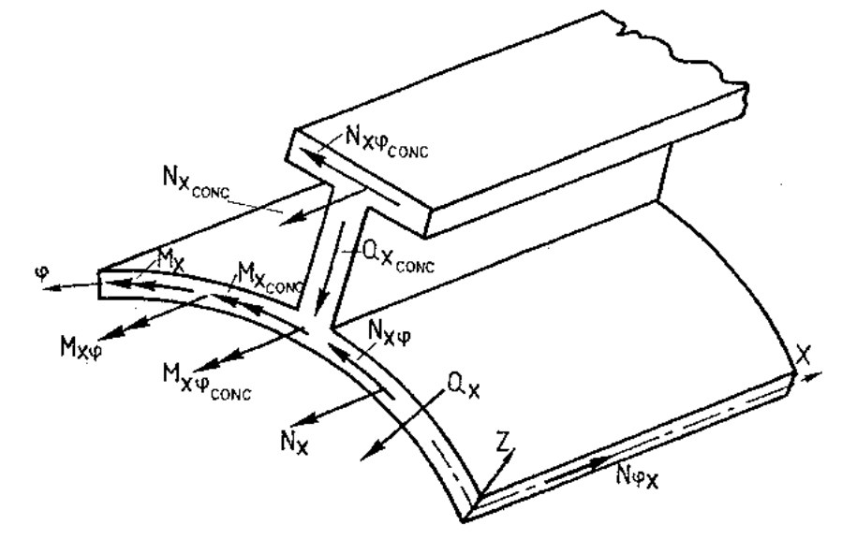

Figure 3: Resultant forces and moments acting on the shell (plate) due to a stiffener.

If we consider a stiffened thin shell element, the “resultant-stress” relationships including the plate and the stiffener components become (Eqs.6):

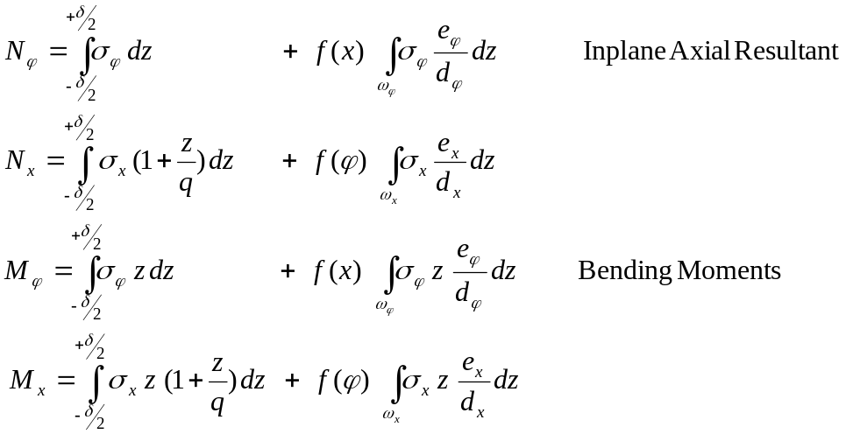 [6]
with ω_{ϕ} and ω_{x} the cross-sections of, respectively, the frame and the stiffeners.

The second term of each equation (Eqs.6) corresponds to the stiffeners f(ϕ) (frames (f(x) ).

Eqs.4 (unstiffened element) are a simplified form of Eqs.6 (stiffened element). Their first terms are identical. For stiffened element the equations (Eqs.6) include Heaviside functions [f(x) and f(ϕ)] that are equal to zero excepted at the stiffener locations [f(x)=1 and f(ϕ)=1]. Figure 4 shows these f(x) and f(ϕ) functions for respectively frame members [f(x)] and longitudinal stiffeners [f(ϕ)].
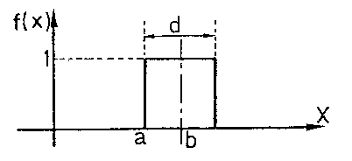
F(x) = H[x-(b-d/2)] - H[x-(b+d/2)]

with H(x) the Heaviside function:
- H(x) = 0 if x <0
- H(x) = 1 if x> 0

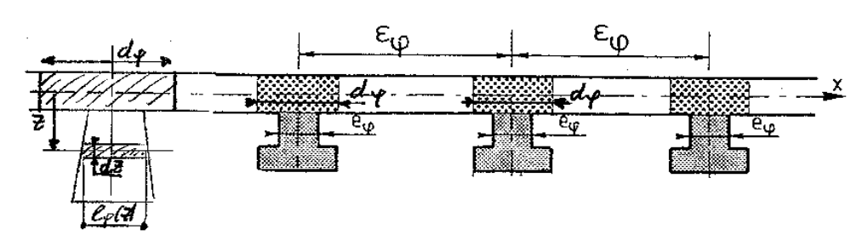

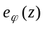

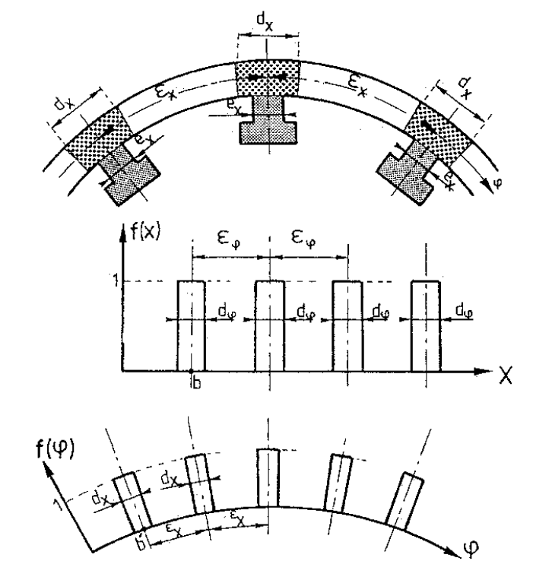

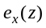

Figure 4: Heaviside functions [f(x) and f(ϕ)]
If we replace the “stress-displacement” relationships [Eqs.2] in the “resultant-stress” relationships [Eqs.6], we obtain the “resultant-displacement” relationships [Eqs.7] for stiffened panels (including stiffeners and frames).

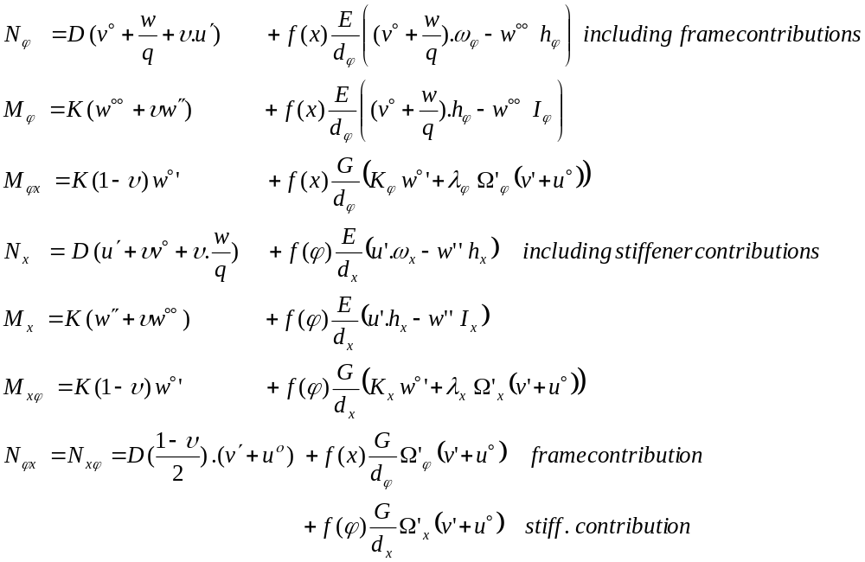 [7a]

with ω_{x} , ω_{ϕ} = transversal section of a stiffener (frame) without plating,
h_{x} , h_{ϕ} = first sectional moment of ω_{x} (ω_{ϕ})  related  to the plate neutral axis z = 0,
I_{x} , I_{ϕ} = second sectional moment of ω_{x} (ω_{ϕ}) related to the plate neutral axis z = 0, it is also called “inertia moment”.
K_{x} , K_{ϕ} = twisting rigidity (or torsional rigidity) of a stiffener (frame),
Ω_{x}', Ω_{ϕ}' = reduced flange section (for flange in-plane shear contribution),
λ_{x} , λ_{ϕ} = flange eccentricity to the plate neutral axis z = 0.
and
d_{x} , d_{ϕ} = strip width where the longitudinal stiffeners (frames) are acting (Figure 4)
A major uncertainty related to the validity of these equations (Eq.7) concerns the flange contribution to the in-plane shear effects (Figure 5).

If these contributions are not considered (N_{xy Conc}=0), we obtain:
STIFFENED SHELL
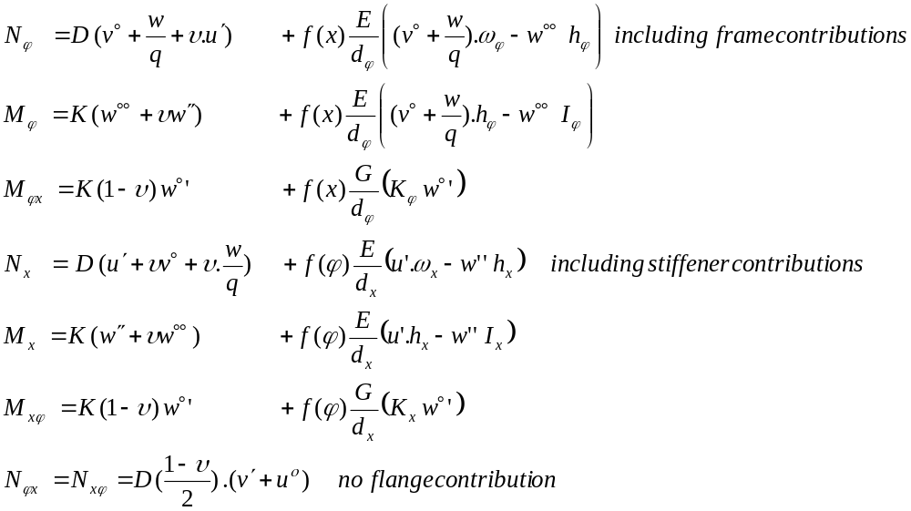[7b]
STIFFENED PLATE
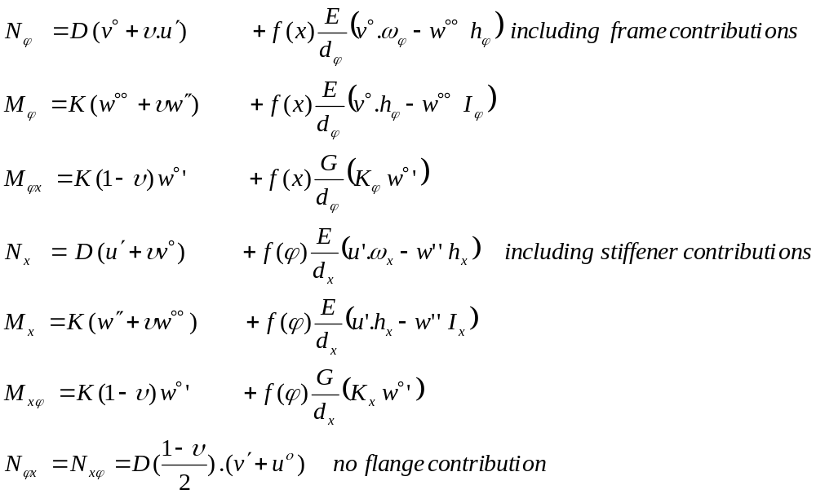 [7c]

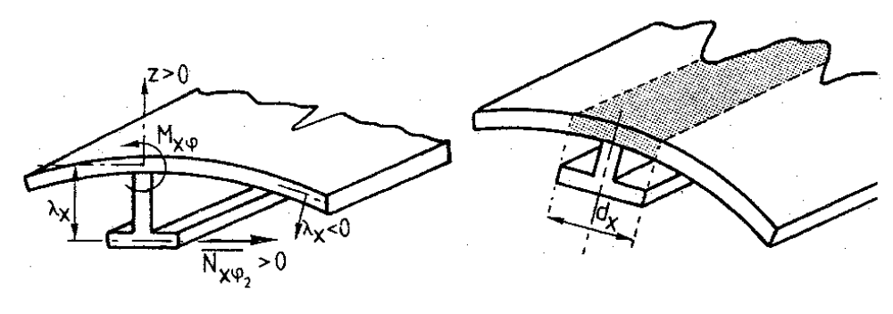

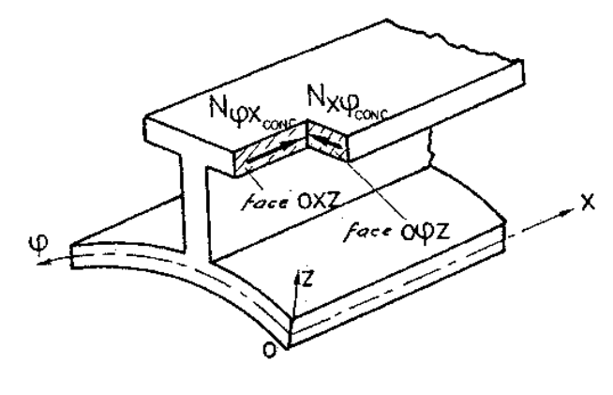

Figure 5: Flange contributions to the in-plane shear resultant (N_{xϕ}) and torsional moment (M_{xϕ})
To resume, the D.K.J. governing differential equations of a cylindrical shell (plate) are obtained by using:

- The 6 equilibrium equations [Eqs.8] (Figure 2):

SHELL PLATE

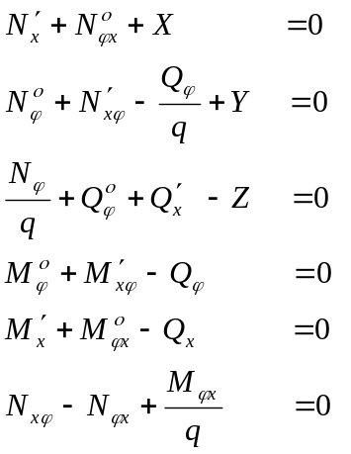 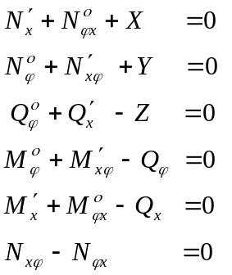 [8]

with X, Y and Z the external loads (N/m²), see Figure 17.

- Using of the 5 hypotheses of linear thin shell theory (see here above),
- Using the “stress-displacement” relationships (Eqs.2) and the “resultant-stress” relationships (Eqs.6) to establish the “resultant-displacement” relationships (Eqs.7).

The problem is composed of 13 unknowns:
- u,v,w
- Nx, Mx, Qx, Nxϕ, Mxϕ
- Nϕ, Mϕ, Qϕ, Nϕx, Mϕx

And there are 13 available equations:
- 4 “resultant-displacement” relationships (Eq.7) corresponding to Nx, Mx, Nxϕ, Mxϕ
(there is no available equation for Q_{x})
- 4 “resultant-displacement” relationships (Eq.7) corresponding to Nϕ, Mϕ, Nϕx, Mϕx
(there is no available equation for Q_{ϕ})
- 5 equilibrium equations (Eq.8)
(the last equilibrium equation has already been used and cannot be considered).

Replacing the “resultant-displacement” relationships (Eqs.7) in the 5 first equilibrium equations (Eqs.8) and replacing Qx and Qϕ (4th and 5th equations) in the 3rd equilibrium equation, we obtain the 3 governing differential equations in u, v and w. This is a system of 3 differential equations.

SHELL WITH SHEAR CONTRIBUTING OF THE FLANGES

Stiffened shell with stiffeners [f(ϕ)] and frames [f(x)]

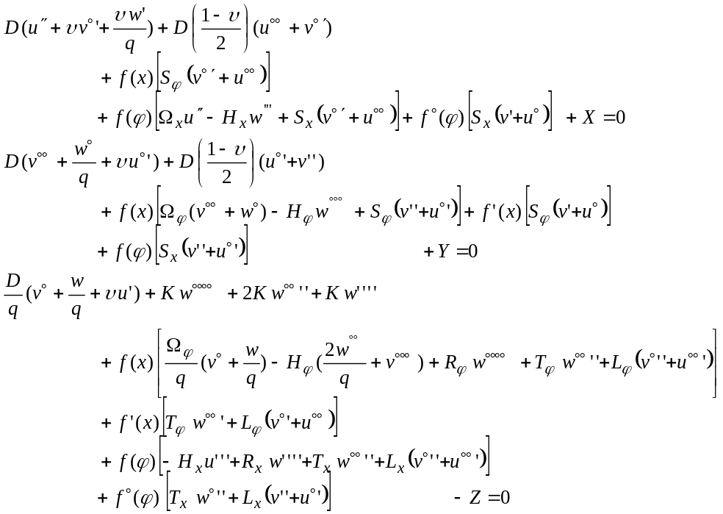 [9]

with

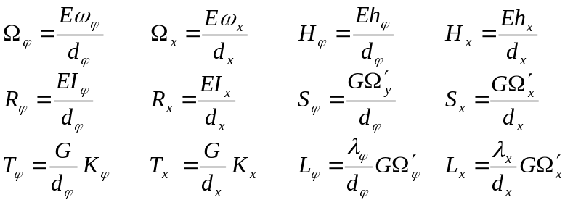

A major uncertainty related to the validity of these equations (Eqs.9) concerns the flange contribution to the in-plane shear effects.
In the next developments (Eqs.10 and 12), these contributions will not be considered. It is a conservative assumption.
SHELL WITHOUT THE FLANGE SHEAR CONTRIBUTING

Stiffened shell with stiffeners [f(ϕ)] and frames [f(x)]
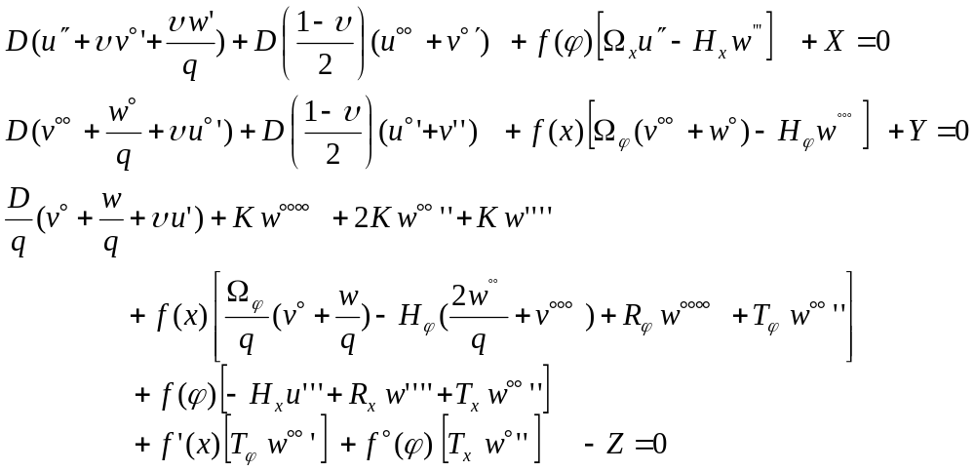 [10]

with
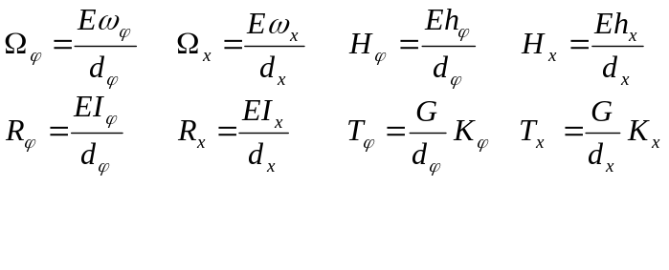
Unstiffened shell

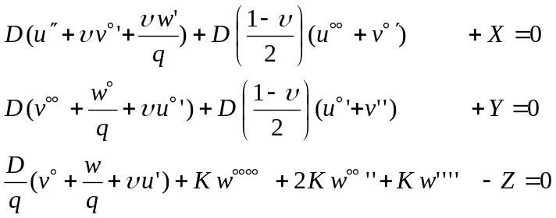 [11]

PLATE WITHOUT THE FLANGE SHEAR CONTRIBUTING

Stiffened plate with stiffeners [f(ϕ)] and frames [f(x)]

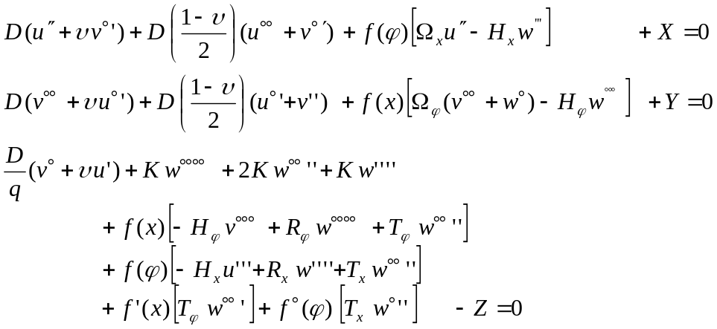 [12]

with

Unstiffened Plate

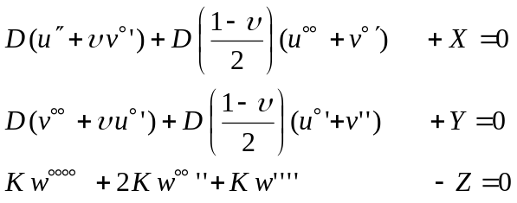 [13]

These equations are not coupled. The bending (3rd equation) can be solved independently of the in-plane forces (1st and 2nd equations).
THE LBR-5’s STIFFENED CYLINDRICAL SHELL (PLATE) ELEMENTS

Figure 6 shows a typical LBR-5 stiffened cylindrical shell element and a typical stiffened plate element. Both are composed of a plating (δ) (curved or not) and 3 layers of stiffeners. Shells are the generic elements and plates are analyzed as a particular case.

There are 2 layers along the longitudinal (ox) direction and 1 layer along the (oϕ) direction.
Typically the layer along oϕ corresponds to the transverse frames.
Longitudinally (ox), there are the stiffeners (smaller in size) and the girders (larger).

It is assumed that:
- all the stiffeners belonging to the same panel are identical and they have the same spacing,
- all the frames belonging to the same panel are identical and they have the same spacing.
On the contrary, the girders can differ, one to the others, and their spacing is free. So the girders can be non-uniformly located.
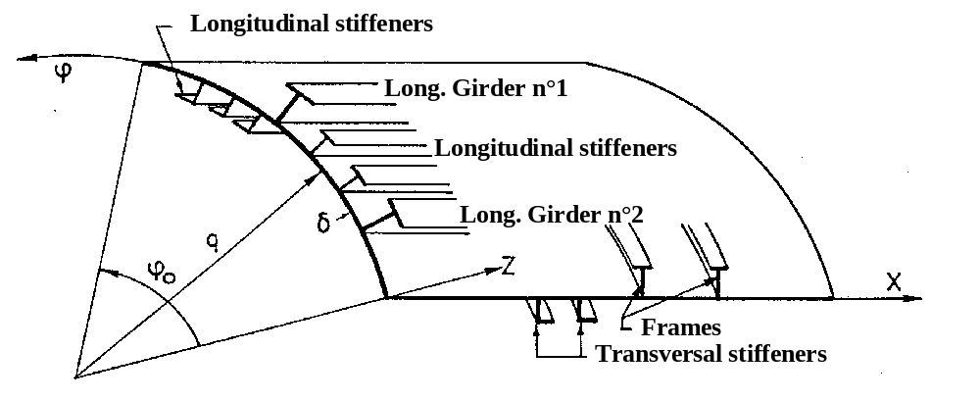

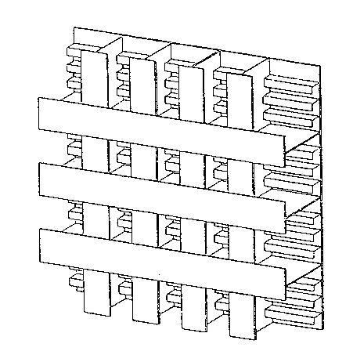

Figure 6: Stiffened cylindrical shell and plate elements
RESULTANT FORCES AND MOMENTS OF THE LBR-5’s THREE LAYERED STIFFENED PANELS

Figure 7 shows the standardization procedure used to consider the stiffener and frame contributions.

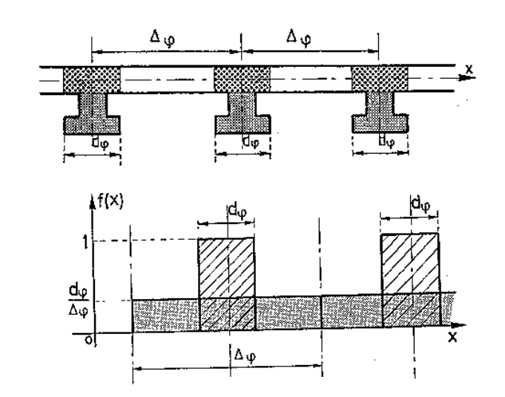

Figure 7: Uniformly distributed frames: 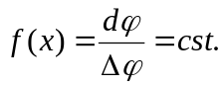

Eqs.14 give the resultant forces and resultant moment of the three-layered stiffened panels.
Eqs.14 present the revised form of the previous set of equations (Eq.7) for shell element with the 3 layers of members (stiffeners, frames and girders).

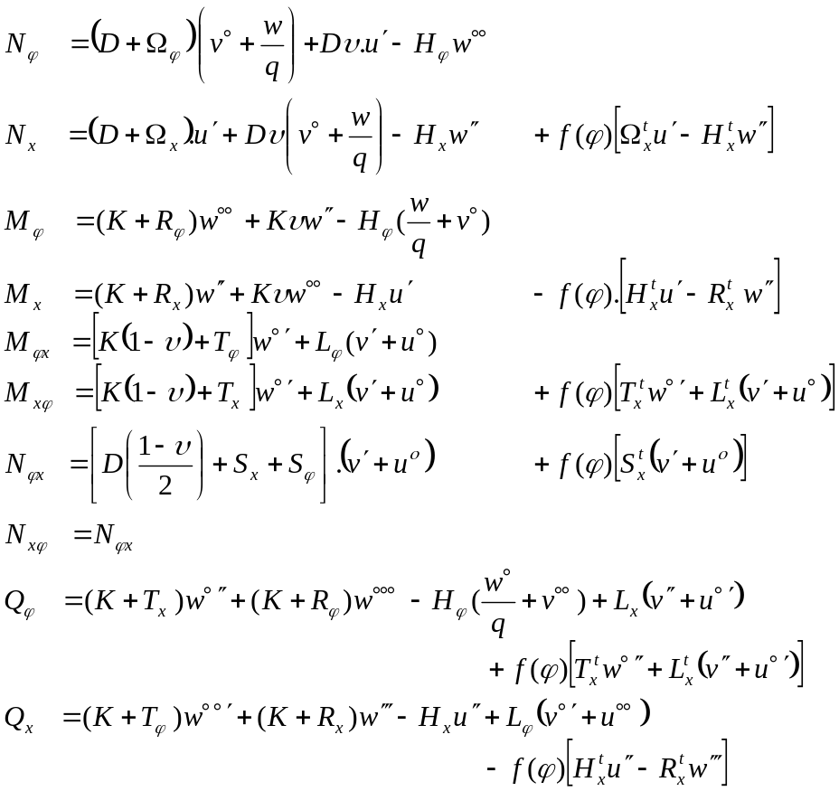 [14]

with for stiffeners (subscript x) and frames (subscript ϕ)

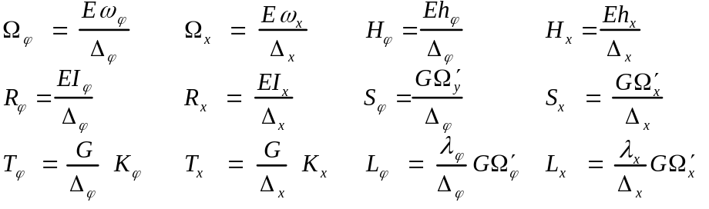

ω_{x} , ω_{ϕ} = transversal section of a stiffener (frame) without plating,
h_{x} , h_{ϕ} = first sectional moment of ω_{x} (ω_{ϕ}) to the plate neutral axis z = 0,
I_{x} , I_{ϕ} = second sectional moment (inertia) of ω_{x} (ω_{ϕ}) to the plate neutral axis z = 0,
K_{x} , K_{ϕ} = twisting rigidity (or torsional rigidity) of a stiffener (frame),
Ω_{x}', Ω_{ϕ}' = reduced flange section (Shear contribution),
λ_{x} , λ_{ϕ} = flange eccentricity to the plate neutral axis z = 0.
Δ_{x} , Δ_{ϕ} = spacing between longitudinal stiffeners (frames),

and for each individual girder (subscript xt)

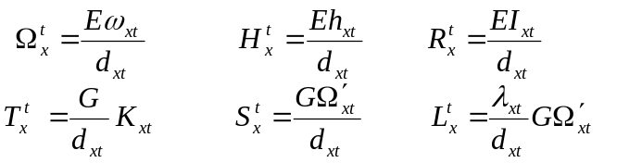

ω_{xt} = transversal section of the girder without plating,
h_{xt} = first sectional moment of ω_{x}   related to the plate neutral axis z = 0,
I_{xt} = second sectional moment of ω_{x} (inertia) related to the plate neutral axis z = 0,
K_{xt} = twisting rigidity (or torsional rigidity) of the girder,
Ω_{xt}' = reduced flange section (Shear contribution),
λ_{xt} = flange eccentricity to the plate neutral axis z = 0.
d_{xt} =  the strip width where the girder is acting.

In Eqs.14 include different components:
- Plate components (terms in D and K),
- Stiffeners components (Ω_{x}, R_{x}, S_{x}, H_{x}, T_{x}, L_{x}),
- Frame components (Ω_{ϕ}, R_{ϕ}, S_{ϕ}, H_{ϕ}, T_{ϕ}, L_{ϕ}) and
- Girder components (Ω_{x}^{t}, R_{x}^{t}, S_{x}^{t}, H_{x}^{t}, T_{x}^{t}, L_{x}^{t} ; terms multiplied by f(ϕ) ).

The f(ϕ) Heaviside functions allow to model the non-uniformity of the girders (in size and in location). The f(ϕ) functions are always equal to zero excepted at the girder locations where f(ϕ)=1 (Figure 4).

On the contrary, for the stiffeners the f(ϕ) function is replaced by d_{ϕ}/Δϕ and for the frames f(x) is replaced by d_{x}/Δx (Figure 7).
This standardization does not mean that the stiffeners (frames) are smeared and replaced by an equivalent plate thickness but it means that each individual characteristic (cross section, first sectional moment, inertia moment, torsional rigidity,…) is standardized on the entire plate. Globally, the stiffened panel behavior is accurately modeled but it is locally simplified. This simplification is only valid if the spacing between stiffeners (frames) is constant and remains small (compared to their span).
Based on the equilibrium equations (Eqs.8) and the “resultant-displacement” relationships (Eqs.14) the 3 governing differential equations are obtained (Eqs.15). In these equations we can distinguish the components related to the plating (D,K), stiffeners (S_{x},Ω_{x},..), frames (S_{ϕ},Ω_{ϕ},..) and girders [f(ϕ).X₀, f(ϕ).Y₀ , f(ϕ).Z₀, f°(ϕ).U_{0X} and f°(ϕ).U_{0Z}].

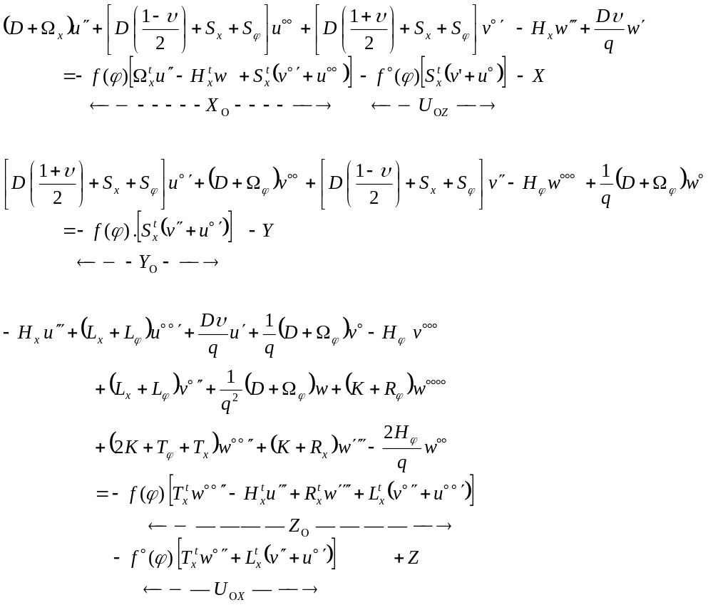 [15]

Related to the girders, one can see that the X₀, Y₀, Z₀, U_{0X} and U_{0Z} components can be considered as external loads (X,Y,Z). These X₀, Y₀, Z₀ loads are in fact “force load lines” (Figure 8) corresponding to the girder reactions on the panels.
Uox and Uoz are “moment load lines”. They correspond to the 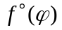 terms.

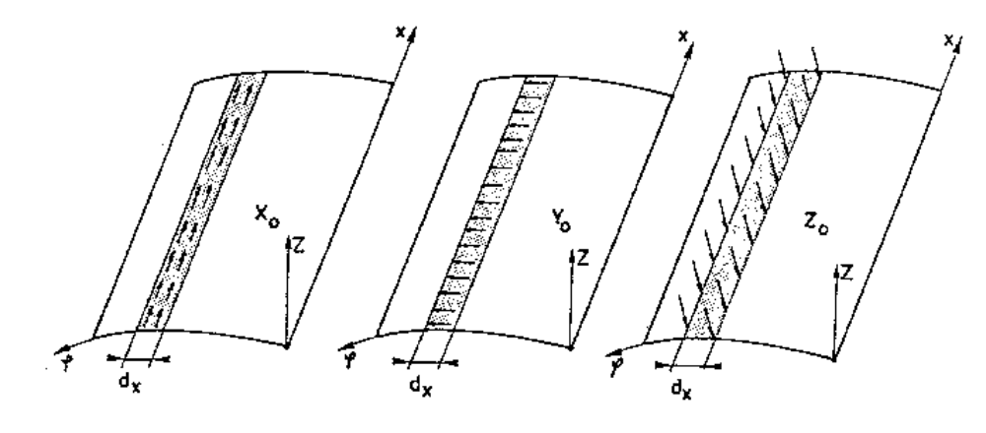

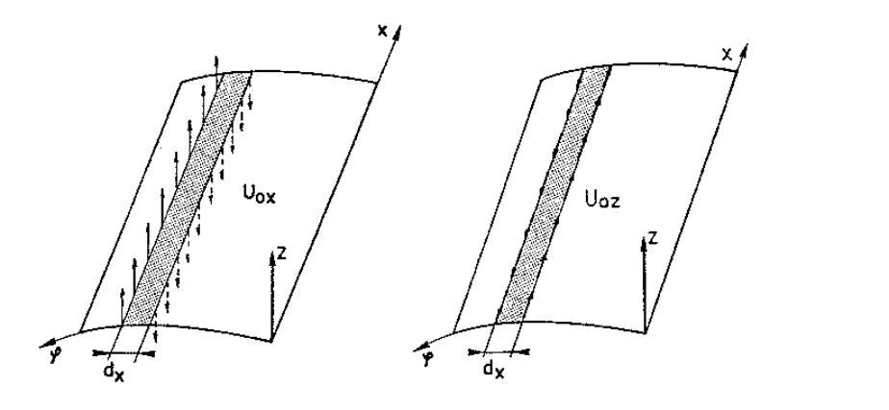

Figure 8: The girder load lines (forces and moments).
AN ANALYTICAL SOLUTION FOR THE STIFFENED PANEL GOVERNING DIFFERENTIAL EQUATIONS

It is only for the unstiffened plate (Eqs.13) that the u and v variables (in-plane displacements) are not coupled with the w transversal displacements (linear thin plate theory).

When shells (unstiffened or stiffened) or stiffened plates are considered, the u, v and w displacements are coupled. The 3 equations have to be solved simultaneously (Eqs.9, 10, 11, 12, 15).

The principle to solve any of these 3 governing differential equations is the same.

These governing equations can be written on the following way:

a₁ u + b₁ v + c₁ w = +X(x,ϕ)
a₂ u + b₂ v + c₂ w = +Y(x,ϕ) [16]
a₃ u + b₃ v + c₃ w = -Z(x,ϕ)

with :
- u(x,ϕ), v(x,ϕ) and w(x,ϕ) the displacements;
- x and ϕ are the coordinates of a point on the mid-plane of the cylindrical shell (plate). The z coordinate does not appear as we only look for the displacements (u, v and w) at the mid-plate thickness where z= 0 (linear thin shell theory).
- X, Y and Z(x,ϕ) are the surface loads (Figure 17).

The a₁, b₁, … and c₃ are the derivative operators. For instance, for the system of Eq.10 we have:

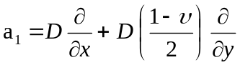

NB: At that stage the f(ϕ) concentrated terms of the differential equations (Eqs.15) corresponding to the girders must be discarded. Their effects will be considered at a latter stage (STEP 6).

STEP 1: HOMOGENEOUS SOLUTION (or Complementary solution)

To get the homogeneous solution of the governing differential equations (Eqs.16) we have to solve the system defined by Eqs.17 (i.e. without the loads).

a₁u + b₁v + c₁w = 0 [17]
a₂u + b₂v + c₂w = 0
a₃u + b₃v + c₃w = 0

This problem (Eqs.17) has a solution if the determinant of the matrix constituted by the derivative operators (a₁, a₂, ..., c₃) is zero (Eqs.18a and 18b).

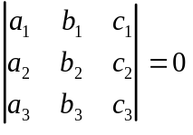 [18a]

or a₁ (b₂c₃ + b₃c₂) + a₂ (b₃c₁ - b₁c₃) + a₃ (b₁c₂ - b₂c₁) = 0 [18b]

If we apply this operator (Eq.18b) to the w(x,ϕ) displacement, we obtain:

[19]

This is an 8th order differential equation with 2 coupled variables (x and ϕ).

Note : w_{ij} means i^{th} order derivative of w by x and j^{th} order derivative by y (y=qϕ ). For instance w₁₃ has the same meaning that w’°°°.

STEP 2: THE FOURIER SERIES EXPANSIONS

To solve this 8th order differential equation we have to make an assumption on the form (shape) of the u,v and w displacements. This assumption is required to obtain an 8th order differential equation with 2 separable variables: w(x,ϕ) = w₁(ϕ) . w₂ (x)

This assumption is satisfy if we use the “Fourier Series Expansion Theory”, i.e. if we assume that:

u(x,ϕ) = u(ϕ) . cos λx
v(x,ϕ) = v(ϕ) . sin λx [20]
w(x,ϕ) = w(ϕ) . sin λx

with λ = nπ/L
n = the term number of the Fourier Series Expansion.
L = Span of the structure (and panels) along ox. L is the same for each panel.

The shape of the displacements used by the Fourier Series Expansion imposes some limitations on the boundary conditions. The 2 edges (x = 0 and x = L) must behave as simply supported edges, i.e.: w = v = M_{x} = N_{x} = 0 (see Figure 9).

If we plug the assumed displacement forms (Eqs.20) in the one of the considered governing differential equations (Eqs.9, 10, 11, 12, 15), Eq.19 becomes an 8th order polynomial differential equation with one single variable (ϕ) instead of 8th order differential equation with two variables (x and ϕ).

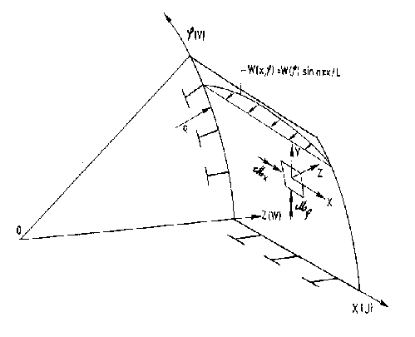
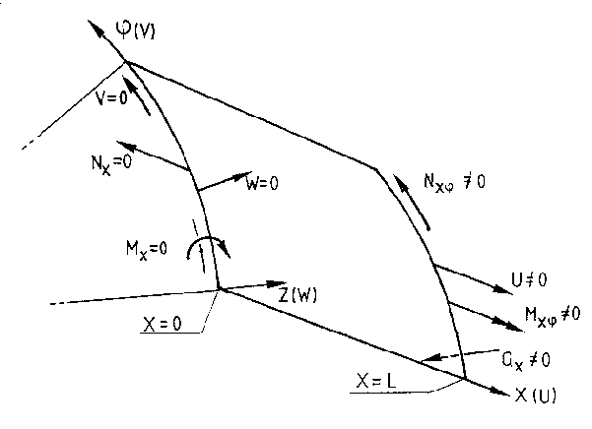

Figure 9: Sine Fourier series expansion and boundary conditions.
STEP 3: THE LOADS’ FOURIER SERIES EXPANSION

Having decided to expand the displacements using Fourier series (STEP 2) to solve the governing differential equations means that the Z(x,ϕ) loads (Eqs.16) have to also satisfy the Fourier series expansion’s shapes:

Z(x,ϕ)= Z*(ϕ) . Q(x) = Z*(ϕ). Σ a sin(λx)].

The way to implement the actual loads in the analytical procedure is explained in STEP 5.

Presented here are the sine and cosine Fourier series expansions of a Q(x) generic load. The basic equation to expand a function Q(x) with sine and cosine series are given by Eqs.21 (Figure 10a).

For a sine expansion

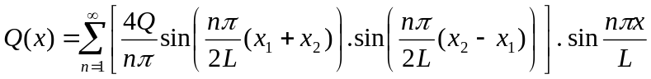 [21a]

For a cosine expansion

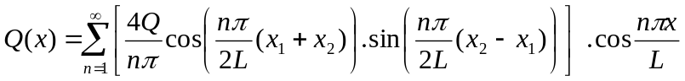 [21b]
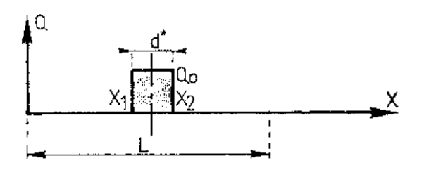

Figure 10.a: Fourier series expansions of a uniform load applied between x₁ and x₂ (along ox).

Hydrostatic pressure is usually uniformly distributed along ox and varies linearly along oϕ. The variation along oϕ is considered in STEP 5. Here we present the expansion along the ox direction.
Figure 10.b shows the Fourier series expansion of a uniformly distributed loads (such as the hydrostatic pressure). This figure and Eq.21.c shows that for a symmetric load only the odd terms are used. So, n of Eq. 21.a is replaced by 2n-1 in Eq.21.c.

In practice, 3 terms are enough to model accurately such loads. They are, in fact, the 1st, 3rd, and 5th terms of Eqs.21a.

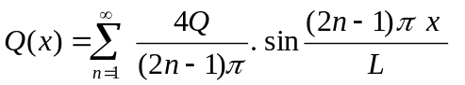 [21c]

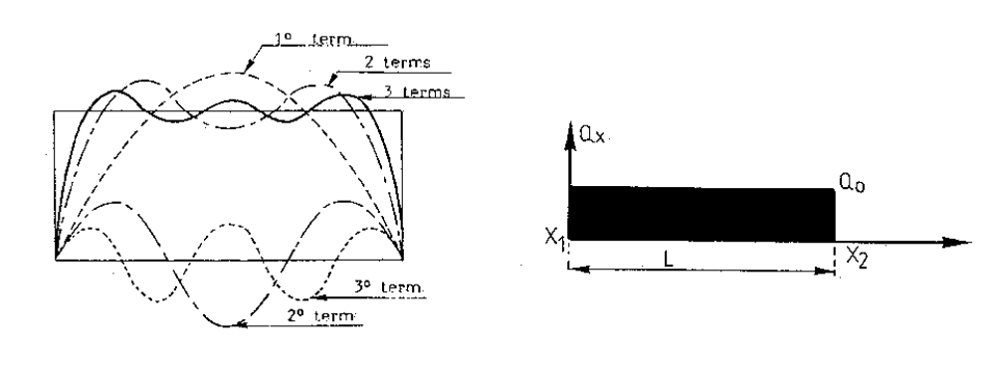

Figure 10b: Fourier series expansions of a uniform load applied between 0 and L (along ox).

Cargo loads and weight distribution are not uniformly distributed. To model such loads we consider that they vary by steps (Figure 11). In such a case about 7-13 terms have to be used. Tests have shown that the use of 100 terms or more does not provide more accurate results.

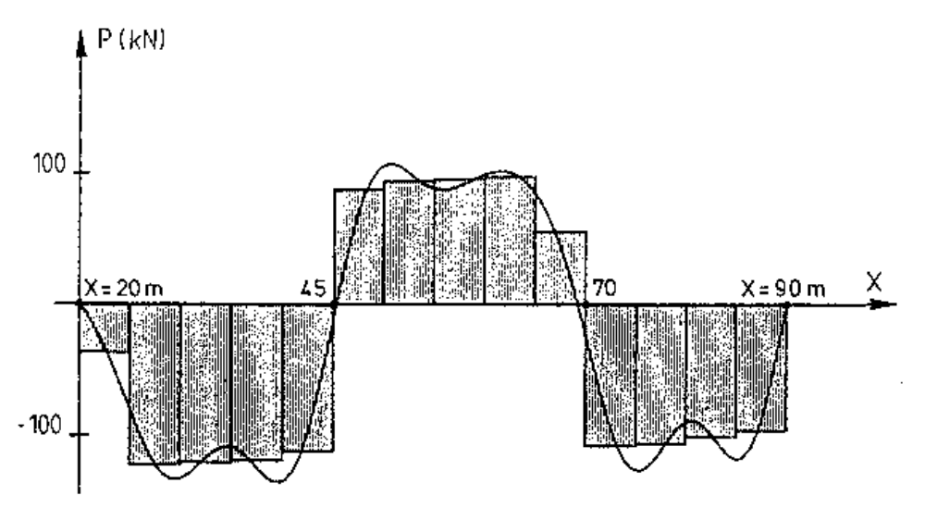

Figure 11: Fourier series expansions (13 terms) of a non-uniformly distributed load (along ox).
To model primary bending moment, it is requested to apply axial longitudinal loads at the both ends of each panel. As concentrated loads cannot be expanded with the Fourier series, these end loads are assumed to be applied on a small zone on each side. The width of these zones is taken in LBR-5 as 1/20 of the span (L). This is a compromise between the number of terms to apply and the accuracy. Figure 12 shows the Fourier series expansion of such axial forces. Note that the forces can be different on the right and on the left as the primary bending moment changes along the hull girder. For such expansions, cosine Fourier series is used. In such a case about 7-13 terms have also to be used.

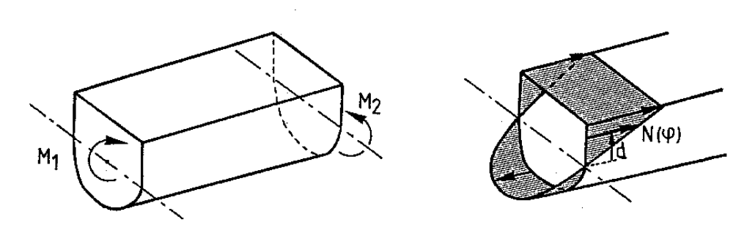

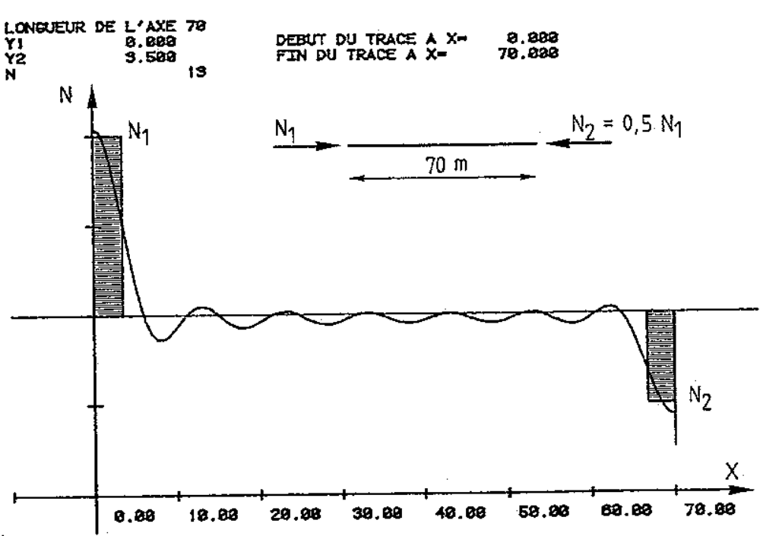

Figure 12: Fourier series expansions (13 terms) of axial loads induced
by the primary hull bending moment.
STEP 4: SOLVE THE 8th ORDER DIFFERENTIAL EQUATION (homogeneous solution)

From the solution of the 8th order polynomial differential equation with a single variable (ϕ) (Eq.19) and keeping in mind that w(x,ϕ) = w(ϕ) sin λx (Eq.20), we obtain:

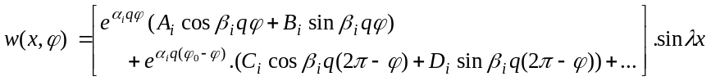 [22]

with i=1 to 2, 3 or 4.

If β₁ and β₂ ≠ 0 then i = 1 to 2 i.e. (α₁, ±β₁),(α₂, ±β₂)
2 complex solutions
If β₁ ≠ 0 and β₂ = 0 or
β₁ = 0 and β₂ ≠ 0 then i = 1 to 3 i.e. (α₁, ±β₁),(α₂,0),(α₃,0)
1 complex and 2 real solutions
If β₁ = β₂ = 0 then i = 1 to 4 i.e. (α₁,0),(α₂,0),(α₃,0),(α₄,0)
4 real solutions

A_{i}, B_{i}, C_{i}, D_{i} are the 8 integration constants included in Eq.22. These constants are determined through the boundary conditions (STEP 5).

For u(ϕ) and v(ϕ) similar equations than Eq.22 can also be written. The u(ϕ) and v(ϕ) equations contain other integration constants that are directly dependent of the 8 integration constants of w (A_{i}, B_{i}, C_{i}, D_{i}.). This means that once these 8 constants are fixed for w, the equations for u and v are also completely defined. In addition, using the “resultant-displacement” relationships (like Eqs.14) the resultant and displacement derivatives (e.g.: w° = slope) are also known. These will be required later (STEP6) to find the boundary forces to apply along the panel boundary edges (ϕ=0 and ϕ=ϕ₀).

Eq.22 for w(ϕ) and those for u(ϕ) and v(ϕ) are defined as to be the “homogeneous solution” of the differential equations.

In fact, due to the procedure followed hereafter (superposition principle) it is not necessary to find a particular solution. The “homogeneous solution” is our basic solution. From this one, the solution of the actual panel can be found.

STEP 5: THE SUPERPOSITION PRINCIPLE

At this stage it is valuable to resume briefly the general philosophy to solve analytically the governing differential equations of structures composed of cylindrical stiffened shells (plates).

The procedure is the following:

A. - To decompose (mesh modeling) the global structure in a series of stiffened cylindrical shells and stiffened plates (Figure 13). More information can be found in the LBR-5 User guide.

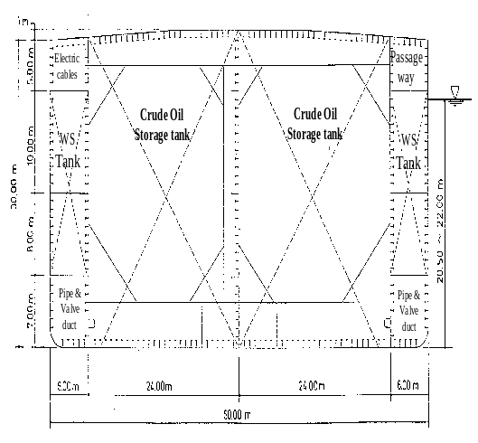
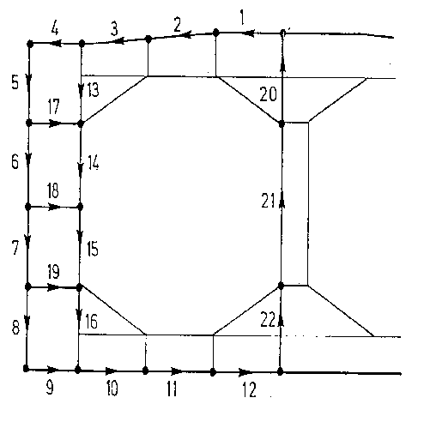

Figure 13: Modeling the structure in stiffened panels

B. - Using the displacement shape of the Fourier Series Expansion, we solve for each panel the governing differential equations without second member (homogeneous solution). At that stage, the f(ϕ) concentrated terms of the differential equations (Eqs.15) corresponding to the girders are discarded. For each panel, (Eq.22) gives the homogeneous solution, which includes the 8 unknown integration constants.

- This procedure (STEP 2 and STEP 7) has to be repeated for each term of the Fourier series expansion. At the end, the superposition principle will be applied by summing all the solutions (one per term) to get the actual solution. The number of terms to use depends on the problem’s complexity of the load patterns. Usually 3-13 terms are required.

- Each panel (cylindrical shell) is considered as being a complete 360° cylinder (i.e. the shell opening angle is 360°). At this stage the actual opening angle (ϕ₀) of the actual panels is not yet considered (Figure 14).
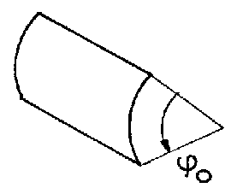

Figure 14:
A stiffened panel with
its actual ϕ₀ opening angle.
C - Definition of the 4 “basic unitary load lines”: X_{u}, Y_{u}, Z_{u}, M_{u} .
The principle is to find the 8 integration constants for the 4 “basic unitary load lines” (Figure 15) applied on the complete cylinder (360°).
This means that 4 sets of integration constants will be determined (one per unitary load line). Based on these 4 basic cases (unitary load lines and 360° cylinder) and using the SUPERPOSITION PRINCIPLE it is possible to find the solution (u,v,w) for the actual stiffened panels [actual opening angle (ϕ₀) and loads (pressure, deadweight, axial compression,…)] that compose the structure.

- The 4 “basic unitary load lines” (Figure 15) applied on the complete cylinder (360°) are the following.

X_{u} = 10,000 cos λx (N/m)
Y_{u} = 10,000 sin λx (N/m) [23]
Z_{u} = 10,000 sin λx (N/m)
M_{u} = 10,000 sin λx (N.m/m)

Their forms are compatible with the Fourier series expansions of the actual loads. These unitary load lines are applied at ϕ = 0.
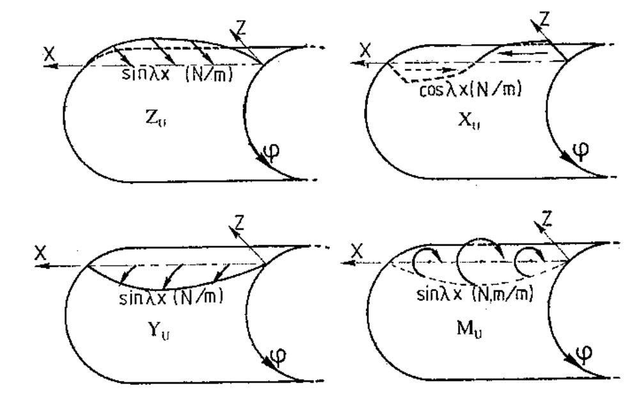

Figure 15: The 4 basic unitary load lines.

- For each of these “unitary load lines” a set of 8 integration constants are obtained through the boundary conditions at ϕ=0 and ϕ = 360°. To satisfy the boundary conditions, we can define 4 equations (equilibrium and/or compatibility). In addition, the symmetry or the anti-symmetry of the resultants and displacements induced by the load line provides 4 other equations (Fig. 16).

For instance for the Z_{u} load case, the conditions are (Figure 16)
v = 0.0 sin λx in ϕ= 0 (per symmetry)
N_{ϕx} = 0.0 cos λx in ϕ= 0 (per symmetry)
w° = 0.0 sin λx in ϕ= 0 (per symmetry)
R_{ϕ} = - 5000 sin λx (N/m) in ϕ=+ε

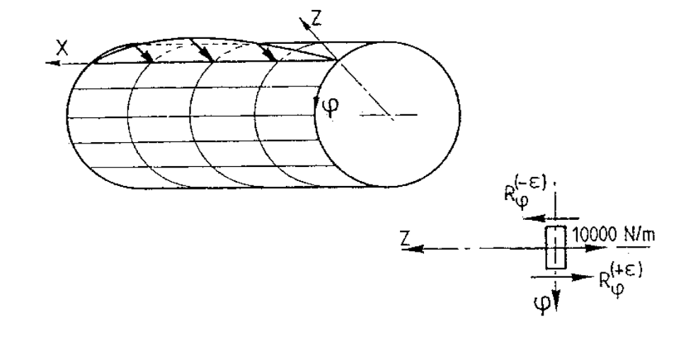

Figure 16: The Z_{u} = 9810 sin λx (N/m) basic unitary load line.

- At this stage, only the stiffeners and the frames are explicitly considered but the girders are not yet considered. Their effects on the global solutions will be added by introducing additional load lines (X₀, Y₀, Z₀, U_{0X} and U_{0Z}). These load lines correspond to the reactions between the panel and the girders. These additional loads line are considered as external loads (Figure 19) applied on the cylindrical shell (plate). This is explained in STEP 6.

- It is also possible to consider the effects of the lateral pressure (varying along oϕ), the deadweight and the longitudinal axial compression (induced by the primary bending moment) by integration the solution(s) obtained for the basic unitary load lines (Figure 17). The unitary load lines (Figure 17) are assumed to be applied on a small surface (L.dy or L.qdϕ) at z=0 (L is the panel length along ox).

Integrating the solutions obtained for the basic load lines according to the actual load distribution (Fig. 17), we get the solutions (u, v and w) for a complete cylinder (360°) submitted to the real load conditions. But still the girder contribution have to be added (see STEP 6).

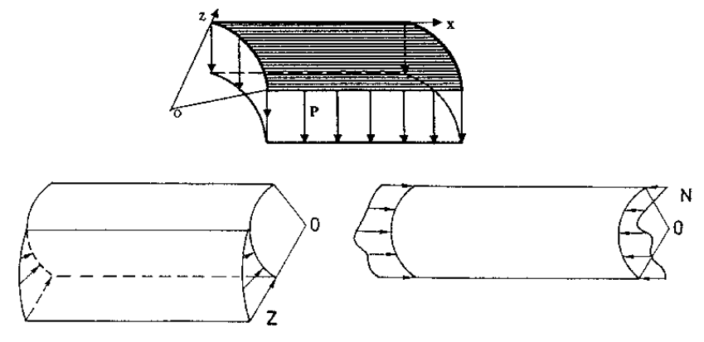

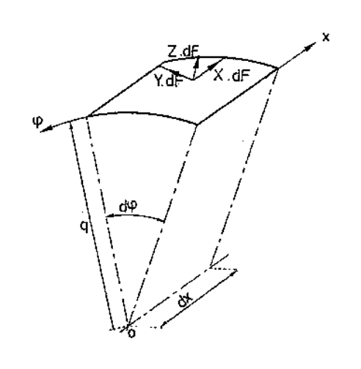
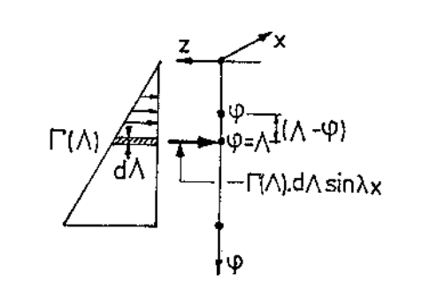

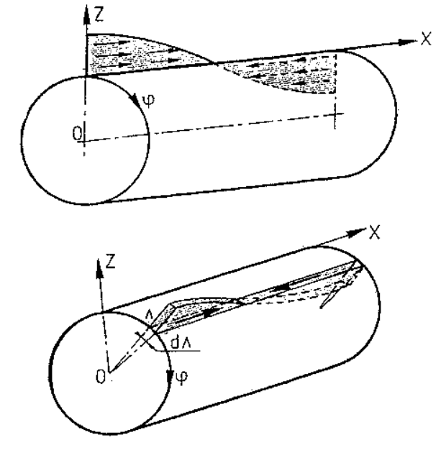

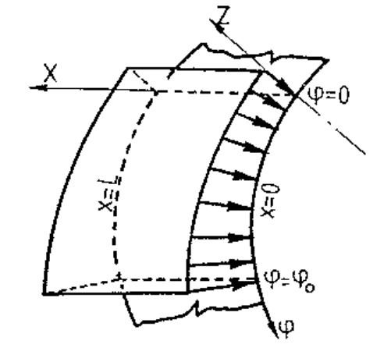

Figure 17: External loads (pressure, deadweight…) and integration procedure
STEP5: THE ACTUAL PANELS

- In order to get the solution of the real panel (for the actual ϕ₀ shell opening angle) we have to consider the actual boundary conditions imposed along the 2 longitudinal edges (ϕ =0 and ϕ= ϕ₀).
NOTE: Even if we look for the solution for the actual panel, the analyzed panel will remain a 360° cylinder that has to satisfy the boundary conditions of the actual panel along the ϕ =0 and ϕ= ϕ₀ edges.

- To satisfy these 2-edge boundary conditions the idea is to apply along each edge (ϕ =0 and ϕ= ϕ₀) a set of 4 basic load lines (X_{u}, Y_{u}, Z_{u} and M_{u}). The problem is to find the amplitude of these load lines. For each panel, the unknowns are the “edge amplification factors” of these load lines (4 acting along the ϕ =0 edge and 4 along the ϕ= ϕ₀ edge). Then, there are 8 unknowns per panel.

- In order to determine these “edge amplification factors”, conditions related to the boundary conditions must be imposed.
- For a free edge, the 4 conditions are: Mϕ = Nϕ = Nxϕ = Rϕ =0
- For a clamped edge, the 4 conditions are: w = v = u = dw/dy =0
- For a simply supported edge, the 4 conditions are: w= u=Mϕ=Nϕ=0
- For an edge (node) corresponding to the junction between 2 panels, we impose 4 compatibility conditions between the displacements of the 2 panels and 4 equilibrium equations,
- For an edge (node) corresponding to the junction between 3 panels, we impose 8 compatibility conditions between the displacements of the 3 panels (4 between panels #1 and #2 and 4 between panel #2 and #3) and 4 equilibrium equations,

- These “edge amplification factors” for all the panels of the structure are determined at the final stage (STEP 7). For a structure composed by N panels, there are 8N unknowns corresponding to the “8 edge multiplication factors” per panel. They are determined by solving a linear problem of 8N equations and 8N unknowns.

- In order to establish the equations (compatibility or equilibrium) at the panel edges, it is necessary to know the displacements (u, v, w, w°) and the resultants (M_{ϕ}, N_{ϕ}, N_{xϕ}, R_{ϕ}) acting along the edge (ϕ = 0) and the edge (ϕ = ϕ₀). This work must be done for the “9 standard loading cases” (Figure 18) that are:
- The actual external loads:
- pressures (quasi-static): Z type,
- gravity loads (deadweight, cargo ...) that have component along oϕ and along oz: Y and Z types,
- axial compression (induced by the primary bending moment) : X type,
- the 4 basic unitary load lines (X_{u}, Y_{u}, Z_{u} and M_{u}) acting at (ϕ = 0),
- the 4 basic unitary load lines (X_{u}, Y_{u}, Z_{u} and M_{u}) acting at (ϕ = ϕ₀).

All these displacements and forces are calculated from the solutions of the homogeneous differential equations for the 4 basic load lines applied on the 360° cylinder (see STEPS 2 and 3).

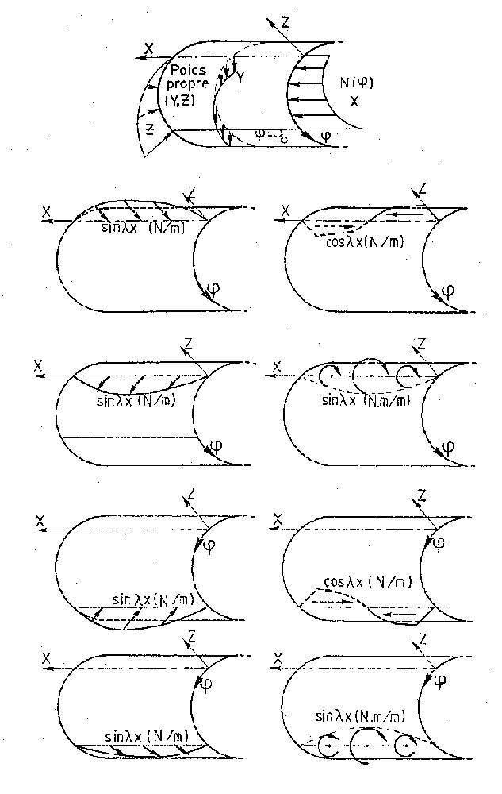

Figure 18: The “9 standard loading cases” (applied on the 360° cylinder)
STEP 6: THE GIRDERS

In order to include the effects of the girders on the stiffened panels it is necessary to evaluate their individual contributions (each girder individually) on the complete cylinder (360°) submitted to the “9 standard loading cases” (Figure 8).
Practically, for each “standard loading case” (external load case, 4 unitary load lines at ϕ=0 and 4 unitary load lines ϕ=ϕ₀) we establish the displacement compatibility and the force equilibrium between the MT girders and the 360° cylindrical shell (which includes stiffeners and frames). So, a linear equations system has to be solved including 5xMT equations (MT being the number of girders of the panel). There is one equation for each girder and for each girder load line (X₀dx, Y₀dx, Z₀dx, U_{0x}, U_{0z}, see Figure 19).

Note that:
- “dx” (Figure 4) is width of the strip where the X₀, Y₀, Z₀ girder forces act. It corresponds to the width where f(ϕ)=1.
- Units of X₀, Y₀, Z₀ are (N/m²) and those of X₀ dx, Y₀ dx, Z₀ dx are (N/m),
- It is better to talk about (X₀dx, Y₀dx, Z₀dx) load lines than (X₀, Y₀, Z₀).

From Eq.15, we obtain that:

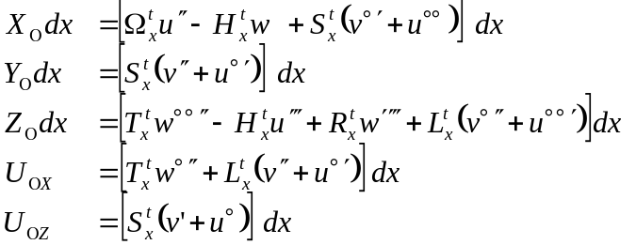 [24a]

If the flange shear contributions (Eqs.10 and 12) are neglected (S_{x}=0 , L_{x}=0):

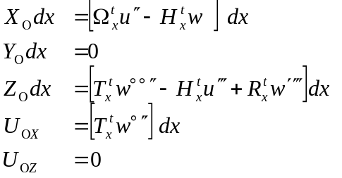 [24b]

Note that the X₀dx, Y₀dx, Z₀dx, U_{0x} load lines are proportional to, respectively, X_{U}, Y_{U}, Z_{U}, M_{U}, basic unitary load lines shown at Figure 15. No the load line is defined to represent U_{0Z}. The reason is that U_{0Z} can be discarded as negligible. Nevertheless, in principle, U_{0Z} can also be considered. It will continue to appear in the next equations.

Let’s consider:
- ϕ=Y, the coordinate of the current line where displacements are calculated,
- ϕ=Λ, the coordinate of the current line where a load line is applied,
- MT girders located at Λ= K_{j}, j=1,MT
- Ψ_{Xo}(K_{j}) ,Ψ_{Yo}(K_{j}) ,Ψ_{Zo}(K_{j}),Ψ_{Uox}(K_{j}) ,Ψ_{Uoz}(K_{j}) the unknown amplitudes of the X₀dx, Y₀dx, Z₀dx, U_{0x}, U_{0z} girder load lines (located at Λ= K_{j}),
- Uo(ϕ),Vo(ϕ),Wo(ϕ) the shell (plate) displacements due to one “standard loading case”.
- U_{Xo}(ϕ),V_{Xo}(ϕ),W_{Xo}(ϕ) the shell (plate) displacements due to an unitary load (Xu = 10000 cosλx ; Fig.15) that is similar to X₀dx (at one constant).
- U_{Yo}(ϕ),V_{Yo}(ϕ),W_{Yo}(ϕ) the shell (plate) displacements due to an unitary load (Yu = 10000 sinλx ; Fig.15) that is similar to Y₀dx (at one constant).
and similarly for [U_{Zo}(ϕ),V_{Zo}(ϕ),W_{Zo}(ϕ)], [U_{Uox}(ϕ),V_{Uox}(ϕ),W_{Uox}(ϕ)] and [U_{Uoz}(ϕ),V_{Uoz}(ϕ),W_{Uoz}(ϕ)].
- (X₀dx)_{Xo, Y=Ki,} _{Λ= Kj} , (Y₀dx)_{Xo, Y=Ki,} _{Λ= Kj} , (Z₀dx)_{Xo, Y=Ki,} _{Λ= Kj} , (U_{0x})_{Xo, Y=Ki,} _{Λ= Kj} ,
and (U_{0z})_{Xo, Y=Ki,} _{Λ= Kj} are the values of the girder load lines at the location of the “i” girder (Y=K_{i}) due to an unitary load Xu = 10000 cosλx applied at the location of the “j” girder (Λ=K_{j}). They are calculated by replacing the displacements [U_{Xo}(ϕ),V_{Xo}(ϕ),W_{Xo}(ϕ)] in (Eq.24) for ϕ=K_{i}-K_{j}
- (X₀dx)_{Yo, Y=Ki,} _{Λ= Kj} , (Y₀dx)_{Yo, Y=Ki,} _{Λ= Kj} , (Z₀dx)_{Yo, Y=Ki,} _{Λ= Kj} , etc.
are the girder load lines at the location of the “i” girder (Y=K_{i}) due to an unitary load Yu = 10000 sinλx applied at the location of the the “j” girder (Λ=K_{j}). They are calculated by replacing the displacements [U_{Yo}(ϕ),V_{Yo}(ϕ),W_{Yo}(ϕ)] in (Eq.24) for ϕ=K_{i}-K_{j} ;
and similarly for
  - (X₀dx)_{Zo, Y=Ki,} _{Λ= Kj} , (Y₀dx)_{Zo, Y=Ki,} _{Λ= Kj} , (Z₀dx)_{Zo, Y=Ki,} _{Λ= Kj} , etc.
  - (X₀dx)_{Uox, Y=Ki,} _{Λ= Kj} , (Y₀dx) _{Uox, Y=Ki,} _{Λ= Kj} , (Z₀dx) _{Uox, Y=Ki,} _{Λ= Kj} , etc.
  - (X₀dx)_{Uoz, Y=Ki,} _{Λ= Kj} , (Y₀dx) _{Uoz, Y=Ki,} _{Λ= Kj} , (Z₀dx) _{Uoz, Y=Ki,} _{Λ= Kj} , etc.
- (X₀dx)_{0, Y=Ki} , (Y₀dx)_{0, Y=Ki} , (Z₀dx)_{0, Y=Ki} , (U_{0x})_{0, Y=Ki} and (U_{0z})_{0, Y=Ki} are the values of the girder load lines at the location of the “i” girder (Y=K_{i}) due to the considered “standard loading case’. They are calculated by replacing the displacements [U₀(ϕ),V₀(ϕ),W₀(ϕ)] in (Eq.24) for ϕ=K_{i}.

Based on this a typical equation is (Eq.25):

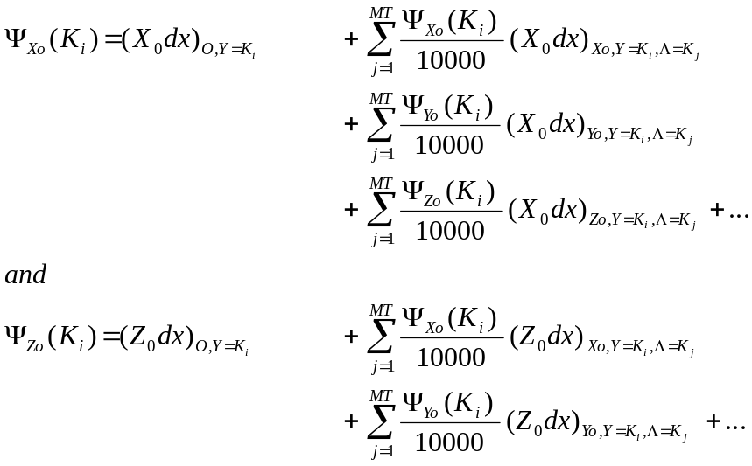 [25]
In principle the five components should be considered but LBR-5 only considers the X₀ and Z₀ components. The 3 others are assumed negligible.
The rigidity matrix of the system (Eq.25) does not change with the load case. So the system has to be solved only once but with 9 different sets of independent terms. For LBR-5, one set of (X₀, Z₀) is obtained for each “standard loading case”.

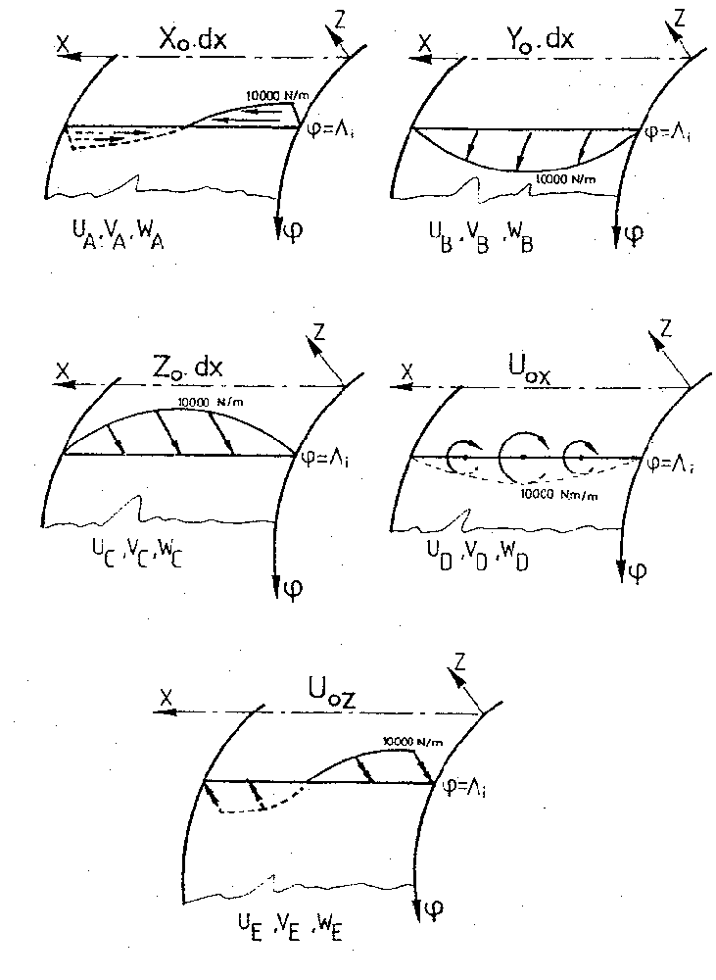

Figure 19: The five “girder unitary load lines”.

In conclusion, one needs for each girder 9 sets of (X₀, Z₀) “girder load lines”. Each set corresponds to one of the “9 standard loading cases”. Then, these girder load lines are applied on the 360° cylindrical shell in addition to the standard loading cases in order to determine the displacements (u, v, w, w°) and the resultants (N_{ϕ}, M_{ϕ}, N_{ϕx}, R_{ϕ}) along the 2 edges (ϕ = 0 and ϕ = ϕ₀).

Having now determined along the boundary edges of each panel all the displacements and resultants (including the girder contribution), we can solve the global system for the complete structure and get the amplification factors (STEP 5) to apply at the 8 “unitary load lines” on each panel (see STEP 7).
STEP 7: FINAL SOLUTION

At the final stage each panel is a 360° cylindrical shell including stiffener and frame contributions but also girders contributions.
For these panels we know the displacements (u, v, w, w°) and the resultants (N_{ϕ}, M_{ϕ}, N_{ϕx}, R_{ϕ}) along their 2 boundary edges (ϕ = 0 and ϕ = ϕ₀) for the “9 standard loading cases”.
To satisfy at the actual boundary conditions of each panel, we determine the “amplification factors” of the 4 “unitary load lines” applied at ϕ=0 and the 4 “unitary load lines” applied at ϕ=ϕ₀. This is done through the compatibility and the equilibrium equations between panels (see STEP5). By solving the global system including all these equations (8 per panel) we get the amplification factors.

Then, the final solutions (u,v,w) of a panel of the structure is obtain by adding 9 different solutions of the same 360° cylindrical panel (including stiffeners, frames and girders):
- the 360° cylindrical panel under actual external loads,
- at ϕ=0, the 360° cylindrical panel under the X_{u}, Y_{u}, Z_{u} and M_{u} “unitary load lines” multiplied by their respective “amplification factor”,
- at ϕ=ϕ₀, the 360° cylindrical panel under the X_{u}, Y_{u}, Z_{u} and M_{u} “unitary load lines” multiplied by their respective “amplification factor”,

Figure 20 shows the use of the superposition principle to get the final solution.

REFERENCES

Rigo Ph. (1989), Utilisation des développements harmoniques aux calculs des ouvrages hydrauliques métalliques, Ph.D thesis, University of Liege, Eds: Collection des Publications de la Faculté des Sciences Appliquées, n°120, Liege, 379 p.

Rigo Ph. (1989), A Software for the Computation and Design of the Stiffened Hydraulic Structures, P.I.A.N.C., Bulletin n°65, 16p.

Rigo Ph. (1992), Stiffened Sheathings of Orthotropic Cylindrical Shells, Journal of Structural Engineering, ASCE, vol 118, n°4, pp926-943.

Rigo Ph. (1992), The Computation of Prismatic Structures, Applied to Naval Architecture, Marine Structures, Elsevier, vol.5, n° 3, pp313-332.

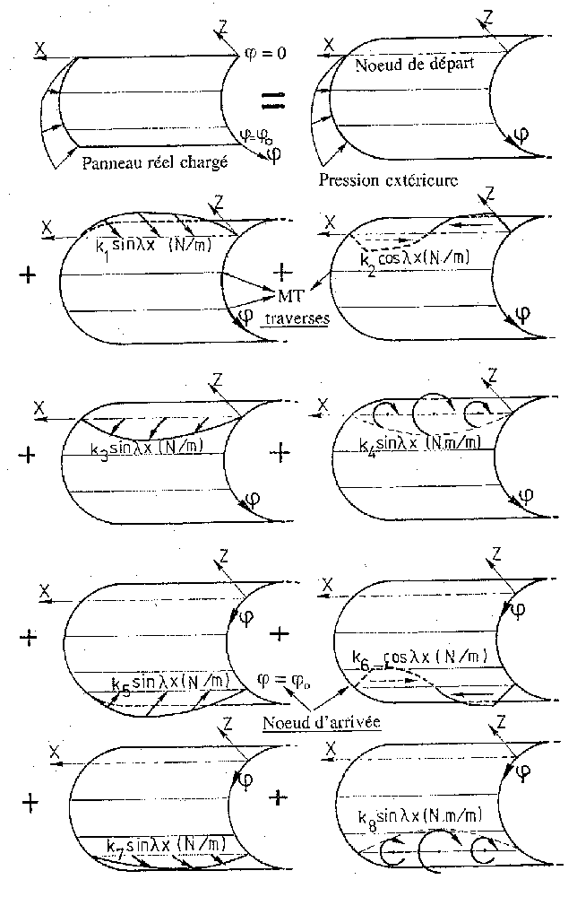

Figure 20:
Final solution using the superposition principle to sum the “9 standard loading cases”.

